**Decorators:**

- Special functions that can add additional functionality to existing functions  
- Call *title_decorator* and pass in *print_my_name* function – this part is tedious, can simplify by adding @ and name of function  
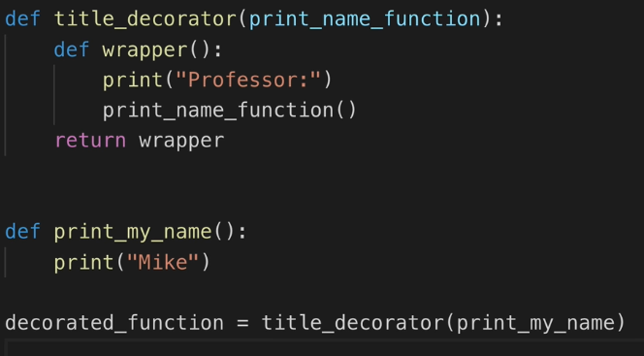  
  
- Easier code with @, need to put directly above code that needs to be wrapped  
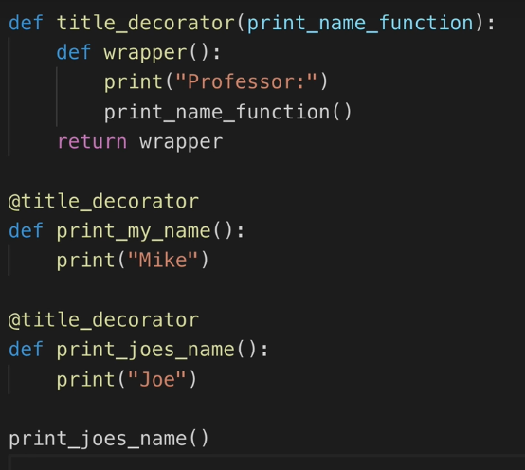

- To take any argument you can modify the code slightly  
